Sync Separator module for PM/PT5664 og PM5661

Powersupply to V1- NE521 reduced to improve reliability :

D5 og D6 to be changed to BZV55-B6V8 (has to be B6v8 due to tolerances)

Code number for BZV55-B6V8: 4008 102 65000
Producent: Philips – ordernumber 9338 277 10115

Additionally zenerdiode BZX79- 3V3 is added
Codenumber: 9331 176 70113

This diode to be mounted with anode on base of Q4 and cathode on ground.
(Viahole to goundplane near C21 is used as connection point of the cathode)

Please refer to photo below

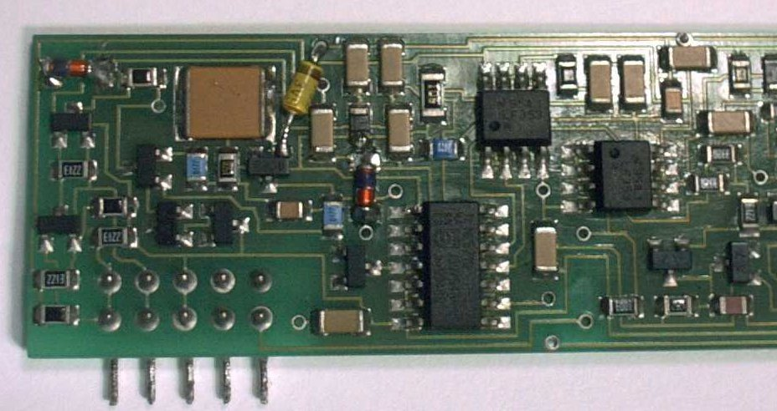
BZV55-B6v8
BZX79 –3v3

